1. 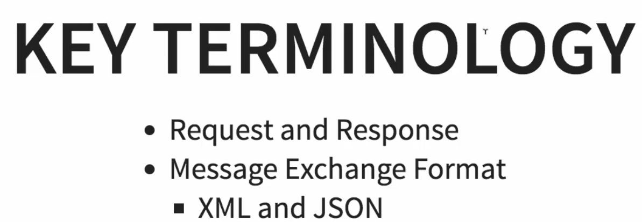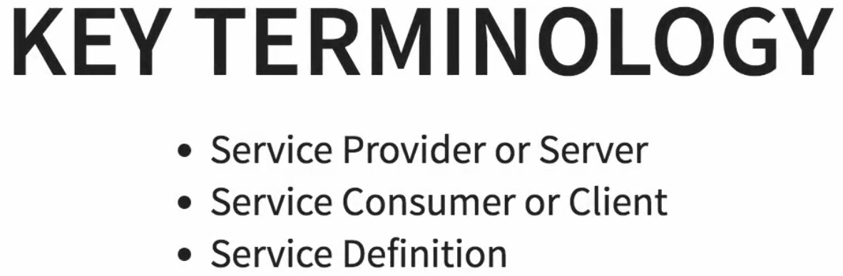
2. **Request**:
   1. An Input to Web-Service.
3. **Response**:
   1. An output to Web-Service
4. **Message Exchange Format**:
   1. Format of the request and response.
   2. Are we using JSON or XML?
5. **Service Provider:**
   1. Web Service is called “**Service Provider**”.
   2. Service Provider is the one which hosts the web service.
6. **Service Consumer:**
   1. Consuming the service from web service.
7. **Service Definition**: It specifies
   1. What is the format of request and response 🡺 XML or JSON?
   2. What is the structure of the request and response?
   3. Where is the web service available?  
      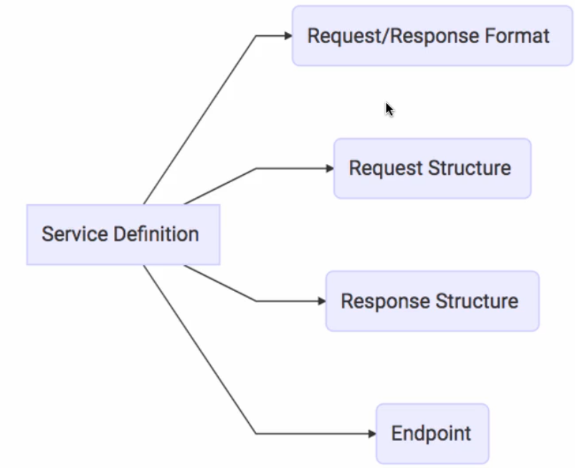
8. **Transport**:
   1. How a service is called?
   2. Is it exposed over HTTP or MQ.
   3. **HTTP**: Then URLs would be given.
   4. **MQ**:
      1. The communication is done over MQ.
      2. The service requester will put message in a queue.
      3. The service provider would be listening to the queue.
      4. The service provider
         1. Takes the request from queue.
         2. Processes it.
         3. Puts the response back on the queue.
9. 